## Douglas Fir - Tanoak (DFTO)

### General Information

### Cover Type Overview

* 6663.61 acres / 2696.67 hectares
* Crosswalks
  + EVeg: Regional Dominance Type 1
    - Pacific Douglas Fir
    - Tanoak
  + EVeg: Regional Dominance Type 2
    - Tanoak (regardless of RD Type 1 value)
  + LandFire BpS Model: 0610430 Mediterranean California Mixed Evergreen Forest (shared with Montane Hardwood)
  + Presettlement Fire Regime Type: Mixed Evergreen
* Ultramafic
  + This type is created by intersecting an ultramafic soils/geology layer with the existing vegetation layer. Where cells intersect with DFTO they are assigned to the ultramafic modifier.

### Vegetation Description

This habitat forms a complex mosaic of forest expression due to the geologic, topographic, and successional variation typical within its range. Deep mesic soils support aggregations that include a lower layer of dense, sclerophyllous, broad-leaved evergreen trees like *Lithocarpus densiflorus* and *Arbutus menziesii* up to 35 m tall, with an irregular, often open, higher layer of tall needle-leaved evergreen trees, typically *Psuedotsuga menziesii*,up to 90 m tall. A small number of pole and sapling trees occur throughout stands. On wet sites, shrub layers are well developed, often with 100 percent cover. Cover of the herbaceous layer under the shrubs can be up to 10 percent. At higher elevations, the shrubs disappear and the herb layer is often 100 percent. Diversity of tree size typically increases with stand age, as does tree spacing. Young stands have closely spaced and uniformly distributed trees, whereas older stands show a more patchy stem distribution. Snags and downed logs, an important structural component of this habitat, increase in density or volume with stand age (Raphael 1988).

Additional hardwood tree associates may include *Quercus chrysolepis*, *Quercus kelloggii*, and *Umbellularia californica*. Potential additional conifer associates include *Abies concolor*, *Pinus lambertiana*, and *Pinus ponderosa* (Tappeiner 1990).

A large variety of shrubs, forbs, grasses, sedges, and ferns are also associated with the Douglas Fir-Tanoak landcover type. Generally these plants are not abundant once the canopy has closed, but, along with *L. densiflorus* sprouts, often become aggressive on burned or cutover areas. Among the most common shrubs are *Ceanothus*, *Corylus*, *Gaultheria*, *Morella*, *Rhododendron*, *Ribes*, *Rubus*, *Toxicodendron diversilobum*, and *Vaccinium*. Common forbs include *Chimaphila*, *Mahonia,* *Cirsium vulgare*, *Erechtites*, and *Whipplea*. Grass species include *Bromus*, *Festuca*, and *Hierochloe*. *Polystichum munitum* and *Pteridium aquilinum* var. *pubescens*) sometimes grow abundantly. *Carex* spp. also are represented in some places (Tappeiner 1990).

* **Ultramafic Modifier** Sites are likely to be dominated by *Pinus jeffreyi* in an open grassland or shrubland. Other tree associates on ultramafics include *P. menziesii*, *C. decurrens, Pinus attenuata,* and *Q. chrysolepis*. Common shrubs include *Ceanothus, Arctostaphylos,* and occasionally *Quercus breweri*. Dominant grasses include *Stipa, Festuca,* and *Danthonia* (LandFire 2007b, McDonald 1988).

### Distribution

Douglas Fir–Tanoak is typically found on soils that are deep, well-drained, and loamy, sandy, or gravelly. It grows in valleys, coves, ravines, along streams, and on north slopes. It is found between elevations of 580 and 1220 m (1,900 and 4,000 ft) (Tappeiner 1990).

* **Ultramafic Modifier**  Low to moderate elevations in ultramafic and serpentinized areas often produce soils low in essential minerals like calcium potassium, and nitrogen, and have excessive accumulations of heavy metals such as nickel and chromium. These sites vary widely in the degree of serpentinization and effects on their overlying plant communities (“CalVeg Zone 1” 2011). Note, the terms “ultramafic rock” and “serpentine” are broad terms used to describe a number of different but related rock types, including serpentinite, peridotite, dunite, pyroxenite, talc and soapstone, among others (O’Geen et al. 2007).

**Disturbances**

### Wildfire

With its flammable leaves and successional position in the understory or subcanopy, tanoak is adapted to catch fire easily. In the lower montane zone of the Sierra Nevada where tanoak occurs, the historic fire regime was characterized by dry-season fires of mostly low to moderate severity. Patchy, stand-replacement fires were most common on north-facing slopes and during extended droughts (Tappeiner 1990). Most fires are started by lightning. There is evidence that Native American burning prior to 1850 may have been extensive (LandFire 2007a).

Tanoak seedlings and saplings are typically top-killed by even low-severity surface fire. Large trees usually survive moderate-severity fire, bearing fire scars afterward. Even tanoaks with thick bark (3-10 cm) typically sustain bole damage from fire. Relative to associated conifers, mature Douglas fir is fairly resistant to surface fires. Crown fires cause extensive mortality (Tappeiner 1990).

For mixed evergreen-tanoak in the Klamath mountains, Skinner and Chang (1996) report a median FRI of 13 years, minimum of 3 years, and a maximum of 41 years. Van de Water and Safford (2011) estimated a mean FRI of 29 years, with a median of 13 years, mean minimum of 15 years and mean maximum of 80 years. The LandFire model for this type (2007a) predict an average FRI of 8 years. Replacement FRI averages 333 years with a range of 65 to 500 years, while surface FRI averages 10 years with a range of 7 to 15 with an average of 10 years. We recalculated these numbers using condition-specific information and using only high and low mortality fire categories, which resulted in an interval of 75 years for high mortality fire, 8 years for low mortality fire, and 8 years for any fire.

* **Ultramafic Modifier** Skinner and Chang (1996) reported fire intervals for *P. jeffreyi* in the Klamath Mountains. They found a median FRI of 13 years, with a minimum of 4 and a maximum of 157. This is a surprisingly short FRI, but these results are consistent with the general consensus that fire intervals on ultramafic sites are longer and more variable than on adjacent non-ultramafic sites. The Landfire model for Klamath-Siskiyou Xeromorphic Serpentine Savanna and Chaparral (2007b) predicted a replacement FRI averaging 200 years with a range of 100-300 years, no mixed severity fire, a surface FRI averaging 15 years with a range of 10-20 years, and an all-fire FRI averaging 14 years. We recalculated these numbers using condition-specific information and using only high and low mortality fire categories, which resulted in an interval of 87 years for high mortality fire, 17 years for low mortality fire, and 14 years for any fire.

Table 1. Fire return intervals (years) and percentage of high versus low mortality fires. Values for DFTO were derived from BpS model 0610430 (Landfire 2007a) and Van de Water and Safford (2011). Values for DFTO on ultramafic soils were derived from BpS model 0711700 (Landfire 2007b).

|  |  |  |  |  |  |  |
| --- | --- | --- | --- | --- | --- | --- |
| **Variant** | **Modifier** | **Fire Severity** | **Average** | **Min** | **Max** | **% of Fires** |
| DFTO | None | High | 75 |  |  | 10 |
| Low | 8 |  |  | 90 |
| All Fires | 8 | 5 | 41 |  |
| Ultramafic | High | 87 |  |  | 16 |
| Low | 17 |  |  | 84 |
| All Fires | 14 | 15 | 80 |  |

### Other Disturbance

Other disturbances are not currently modeled, but may, depending on the condition affected and mortality levels, reset patches to early development, maintain existing stages, or shift/accelerate succession to a more open stage. All of the tree species associated with this vegetation type are susceptible to a wide variety of pathogens and insects.

### Vegetation Condition Classes

### Early Development (ED)

**Description** Grasses, Abundant grasses, forbs, low shrubs, and sparse to moderate cover of trees (primarily *P. menziesii* and *L. densiflorus*) seedlings/saplings with an open canopy. This condition is characterized by the diversity of species establishing and reestablishing into an open area created by a stand-replacing disturbance.

Seedling establishment of *P. menziesii* following fire is dependent on the spacing and number of surviving seed trees. Seedling establishment following large stand-destroying fires may be slow if seed trees are killed over extensive areas. Or, if there are numerous, well-spaced surviving seed trees within the burned area, a new cohort of seedlings can quickly establish (Uchytil 1991).

Nearly all tan oak burls sprout after fire, and survivorship is high. *Q. chrysolepis*, if present, also sprouts readily, and shrubs such as *Mahonia*, *Gaultheria*, and *Rhododendron* may be significant. Shrub growth from seed banks, e.g. *Ceanothus integerrimus*, can also be high (LandFire 2007a).

On ultramafic sites, grasses like *Festuca, Danthonia*, and *Acnatherum,* or else chaparral shrubs establish alongside scattered *P. jeffrei* (LandFire 2007b).

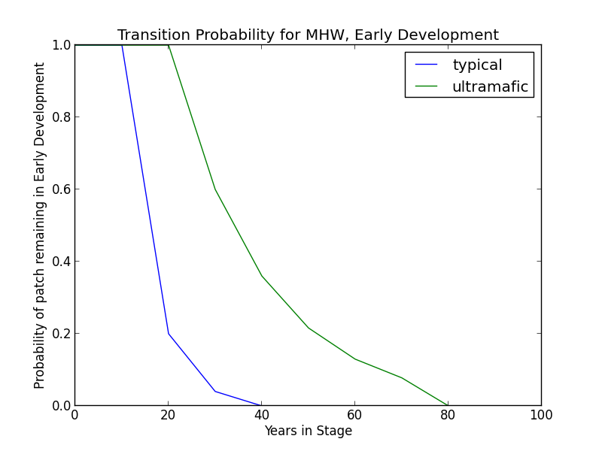**Succession Transition** In the absence of disturbance, this class will begin transitioning to mid development after 20 years. The probability of succession per time step is 0.8. At 40 years, all stands will have succeeded.

* **Ultramafic Modifier** Succession may be delayed. Thus, in the absence of disturbance, this class will begin transitioning to MD after 30 years and may be delayed in the ED stage for as long as 80 years. A stand in this condition has a probability of 0.4 that it will succeed.

**Wildfire Transition** High mortality wildfire (100% of fires) recycles the patch through the Early Development stage. Low mortality wildfire is not modeled for this stage.

**Mid Development (MD)**

**Description** Sparse ground cover of grasses, forbs, and shrubs; moderate but most likely dense cover of trees (primarily *P. menziesii* and *L. densiflorus*). Other *Quercus* and *Arctostaphylos* species may also be present. In this stage, hardwoods are dominant (40-100% canopy cover), but *P. menziesii* and possibly other conifers are established or establishing under the predominantly *L. densiflorus* canopy (LandFire 2007a, McDonald 1988). Ultramafic sites are characterized by open *P. jeffreyi* stands with an understory comprised of grasses, forbs, and shrubs (LandFire 2007b).

**Succession Transition** After 20 years without a wildfire-triggered transition, this class will begin transitioning to late development. The probability of succession per time step is 0.8. At 40 years, all stands will have succeeded.

* 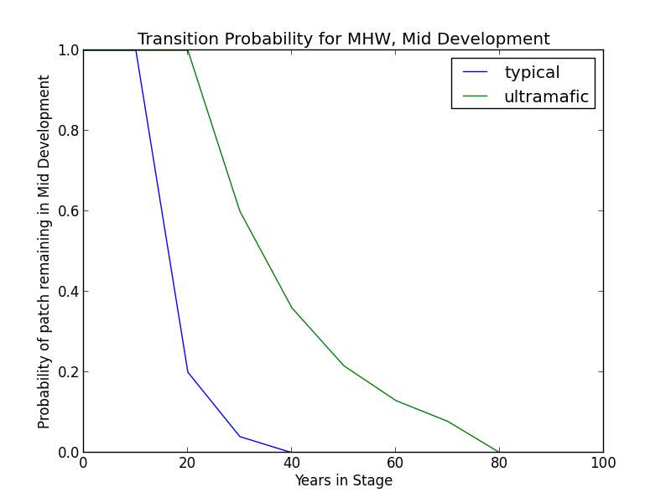**Ultramafic Modifier** Succession may be delayed. Thus, in the absence of disturbance, this class will begin transitioning to LD after 30 years and may be delayed in the MD stage for as long as 80 years. A stand in this condition has a probability of 0.4 that it will succeed.

**Wildfire Transition** High mortality wildfire (2.5% of fires) recycles the patch through the Early Development stage. Low mortality wildfire (97.5%) does not effect a change in the MD condition.

* **Ultramafic Modifier** High mortality wildfire (7.0% of fires) recycles the patch through the Early Development stage. Low mortality wildfire (93.0%) does not effect a change in the MD condition.

**Late Development (LD)**

**Description** Overstory of large and very large conifers, primarily *P. menziesii*. Canopy cover exceeds 60%. *P. lambertiana* also occurs. *L. densiflorus* is tolerant of both full sun and shade, and usually dominates the subcanopy at this stage. Co-dominance of the upper canopy with *P. menziesii* is uncommon but possible after extended periods without disturbance. *Quercus* and *Arctostaphylos* species may also be present in the sub-canopy (Uchytil 1991, LandFire 2007a).

On ultramafic sites, large *P. jeffreyi* are the primary conifer species. Grass savannah persists on sites experiencing low intensity fire (with *Festuca, Achnatherum,* and *Danthonia*). Where fire is less frequent, chaparral shrubland develops (with *Arctostaphylos* and *Quercus breweri*) (LandFire 2007b).

**Succession Transition** In the absence of disturbance, this class will maintain, regardless of soil characteristics.

**Wildfire Transition** High mortality wildfire (2.5% of fires) recycles the patch through the Early Development stage. Low mortality wildfire (97.5%) does not effect a change in the MD condition.

* **Ultramafic Modifier** High mortality wildfire (7.0% of fires) recycles the patch through the Early Development stage. Low mortality wildfire (93.0%) does not effect a change in the MD condition.

**References**

“CalVeg Zone 1.” Vegetation Descriptions. *Vegetation Classification and Mapping*. 11 December 2008. U.S. Forest Service. <http://www.fs.usda.gov/Internet/FSE_DOCUMENTS/fsbdev3_046448.pdf>. Accessed 2 April 2013.

LandFire. “Biophysical Setting Models.” Biophysical Setting 0610430. Zone 6. 2007a. LANDFIRE Project, U.S. Department of Agriculture, Forest Service; U.S. Department of the Interior. <http://www.landfire.gov/national_veg_models_op2.php>. Accessed 9 November 2012.

LandFire. “Biophysical Setting Models.” Biophysical Setting 0711700. 2007b. LANDFIRE Project, U.S. Department of Agriculture, Forest Service; U.S. Department of the Interior. <http://www.landfire.gov/national_veg_models_op2.php>. Accessed 30 November 2012.

McDonald, Philip M. “Montane Hardwood (MHW).” *A Guide to Wildlife Habitats of California*. 1988. Mayer, Kenneth E. and Laudenslayer, William F., eds. California Deparment of Fish and Game. <http://www.dfg.ca.gov/biogeodata/cwhr/pdfs/MHW.pdf>. Accessed 4 December 2012.

O’Geen, Anthony T., Dahlgren, Randy A., and Sanchez-Mata, Daniel. “California Soils and Examples of Ultramafic Vegetation.” Barbour, Michael, Keeler-Wolf, Todd, and Schoenherr, Allan A., eds. *Terrestrial Vegetation of California, 3rd Edition*. 2007. pp. 71-106.

Raphael, Martin G. “Douglas-Fir (DFR).” *A Guide to Wildlife Habitats of California*. 1988. Mayer, Kenneth E. and Laudenslayer, William F., eds. California Deparment of Fish and Game. <http://www.dfg.ca.gov/biogeodata/cwhr/pdfs/DFR.pdf>. Accessed 4 December 2012.

Skinner, Carl N. and Chang, Chi-Ru. “Fire Regimes, Past and Present.” *Sierra Nevada Ecosystem Project: Final report to Congress, vol. II, Assessments and scientific basis for management options*. Davis: University of California, Centers for Water and Wildland Resources, 1996.

Tappeiner, John C., McDonald, Philip M., Roy, Douglass F. 1990. “Tanoak.” Silvics of North America: 2. Hardwoods. Agriculture Handbook 654. Burns, Russell M., and Barbara H. Honkala, tech. cords. U.S. Department of Agriculture, Forest Service. <http://www.na.fs.fed.us/spfo/pubs/silvics_manual/volume_2/quercus/chrysolepis.htm>. Accessed 7 December 2012.

Thornburgh, Dale A. 1990. “Quercus chrysolepis.” Silvics of North America: 2. Hardwoods. Agriculture Handbook 654. Burns, Russell M., and Barbara H. Honkala, tech. cords. U.S. Department of Agriculture, Forest Service. <http://www.na.fs.fed.us/spfo/pubs/silvics_manual/volume_2/quercus/chrysolepis.htm>. Accessed 7 December 2012.

Uchytil, Ronald J. 1991. “*Pseudotsuga menziesii var. menziesii”*. Fire Effects Information System. U.S. Department of Agriculture, Forest Service, Rocky Mountain Research Station, Fire Sciences Laboratory. <http://www.fs.fed.us/database/feis/plants/tree/psemenm/all.html>.

Van de Water, Kip M. and Safford, Hugh D. “A Summary of Fire Frequency Estimates for California Vegetation Before Euro-American Settlement.” *Fire Ecology* 7.3 (2011): 26-57. doi: 10.4996/fireecology.0703026.